

***FOODCONNECT: TO SUPPLY LEFTOVER FOOD TO POOR***



PREPARED BY:

harshita sharma

Harshitasharma5588@gmail.com

**ABSTRACT:**

The Salesforce-based project is designed to offer a sustainable solution for redistributing surplus food, effectively tackling both food waste and hunger. It connects food donors—such as restaurants, hotels, and event organizers—with organizations like NGOs, shelters, and community kitchens that serve those in need. By leveraging Salesforce's powerful CRM and automation tools, the platform simplifies the process for donors to register surplus food, which is then efficiently matched with nearby recipients based on real-time needs and logistical considerations.

The project features automated notifications for both donors and recipients, smart scheduling to ensure timely pickups and deliveries, and tracking systems to monitor the food’s journey from donor to recipient. It also integrates mapping and route optimization tools to minimize transportation time and reduce carbon emissions.

To foster continuous improvement, the platform offers detailed analytics on food donations, recipient needs, and operational performance. These insights help enhance the distribution network, pinpoint areas with the greatest need, and strengthen relationships with donors. The platform also includes community engagement features, such as donor recognition programs and impact reports that showcase the positive outcomes of their contributions.

Through these features, the Salesforce project not only addresses immediate food insecurity but also creates a scalable model that communities around the world can adopt to effectively combat hunger and reduce food waste.

**INDEX:**

* Introduction
* Object
* Tabs
* The lightening app
* Fields
* Flows
* Trigger
* Profiles
* Creation of users
* Public group
* Report types
* Reports
* Dashboards
* Sharing rules
* Homepage
* Conclusion

**INTRODUCTION:**

Food waste is a pressing global challenge, with vast amounts of edible food being discarded each year while millions of people grapple with hunger and food insecurity. This stark contrast underscores the urgent need for innovative solutions that can bridge the gap between food abundance and those in need. The Salesforce project tackles this issue by developing a streamlined, efficient, and scalable platform for redistributing surplus food.

Utilizing Salesforce’s powerful CRM and automation features, the project connects food donors—such as restaurants, hotels, and event venues—with organizations that support the underprivileged, including NGOs, shelters, and community kitchens. The platform simplifies the donation process, ensuring that surplus food reaches its destination quickly and safely. By automating notifications, optimizing logistics, and offering real-time tracking, the system effectively reduces food spoilage and maximizes the impact of surplus food.

This initiative not only addresses food waste but also enhances social welfare by providing nourishment to those in need. The Salesforce-based platform aspires to create a sustainable and adaptable model that can be implemented globally, promoting a fairer distribution of resources and addressing the critical issue of food insecurity.

**OBJECT:**

Salesforce objects are key components used to store and manage data within the Salesforce platform. There are two main types:

1. **Standard Objects:** Pre-built objects provided by Salesforce, such as:
   1. **Account:** Stores information about organizations like food donors or recipient NGOs.
   2. **Contact:** Holds details about individuals associated with these organizations.
   3. **Opportunity:** Tracks potential food donations through various stages.
   4. **Case:** Manages issues that arise during the food distribution process.
2. **Custom Objects:** User-defined objects tailored to specific needs, such as:

* **Venue:** Stores information about locations where surplus food is available, such as restaurants, hotels, or event sites.
* **Dropoff Point:** Captures details of locations where food will be delivered, such as shelters, NGOs, or community kitchens.
* **Task:** Manages specific actions or steps needed in the food redistribution process, like scheduling pickups, coordinating with volunteers, or confirming deliveries.
* **Volunteer:** Tracks details about individuals who are helping with the food distribution, including their availability, assigned tasks, and contact information.
* **Execution Details:** Holds information on the actual implementation of food distribution activities, including logistics, timing, and any issues encountered during the process.

1. **Create Customer DetailsObject**

To create an object:

From the setup page >> Click on Object Manager >> Click on Create >> Click on Custom Object.

Enter the label name >> Customer Details

Plural label name >> Customer Details

Enter Record Name Label and Format

Record Name >> Customer Name

Data Type >> Text

Click on Allow reports and Track Field History,

Allow search >> Save

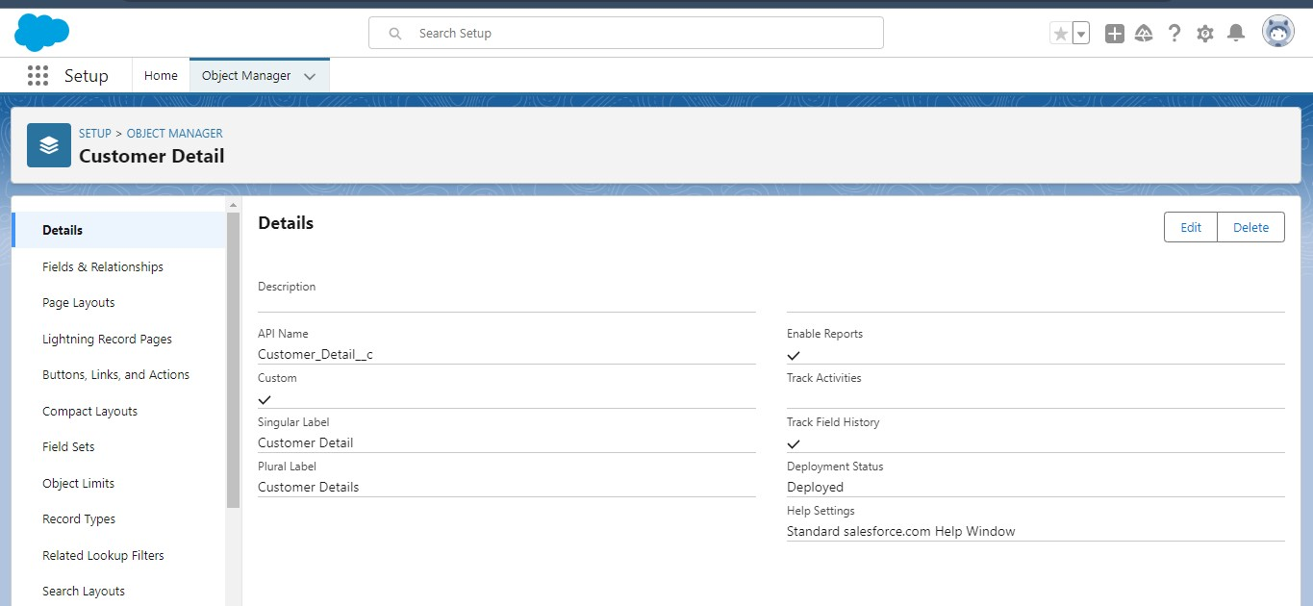

1. **Create Venue Object**

To create an object:

From the setup page >> Click on Object Manager >> Click on Create >>Click on Custom Object.

Enter the label name >> Venue

Plural label name >> Venues

Enter Record Name Label and Format

Record Name >> Venue Name

Data Type >> Text

Click on Allow reports and Track Field History,Allow Activities.

Allow search >> Save.

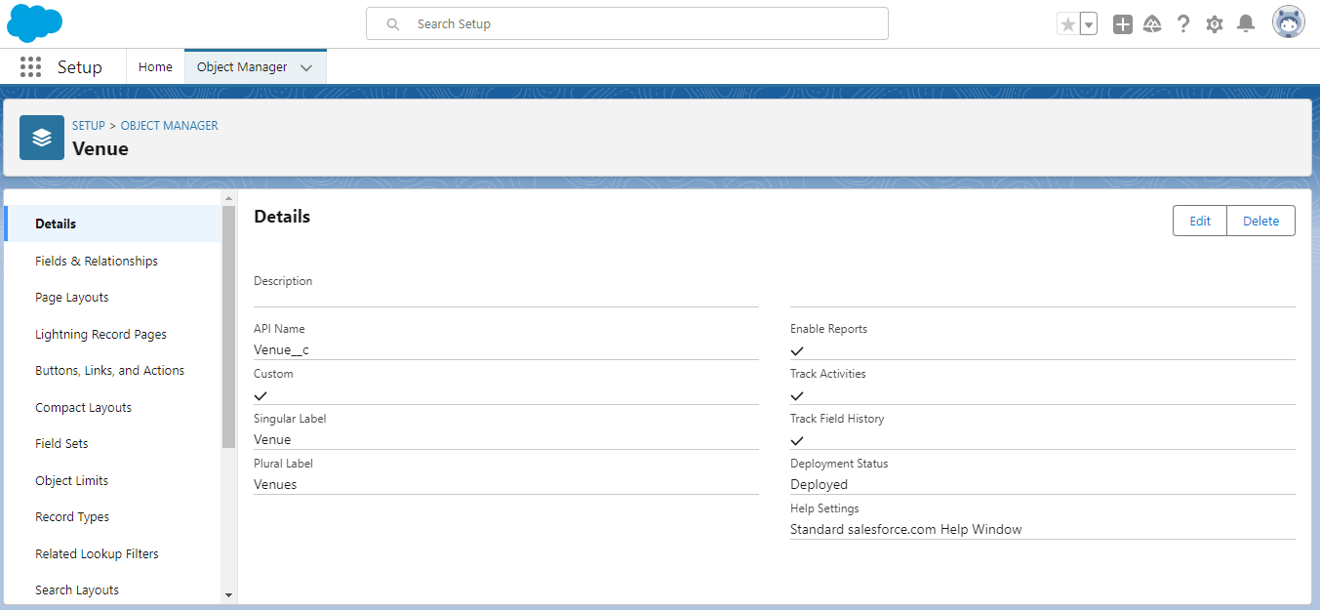

1. **Create Drop-Off Point Object**

To create an object:

From the setup page >> Click on Object Manager >> Click on Create >> Click on Custom Object.

Enter the label name >> Drop-Off Point

Plural label name>> Drop-Off Points

Enter Record Name Label and Format

Record Name >> Drop-Off point Name

Data Type >> Text

Click on Allow reports and Track Field History,Allow Activities

Allow search >> Save.

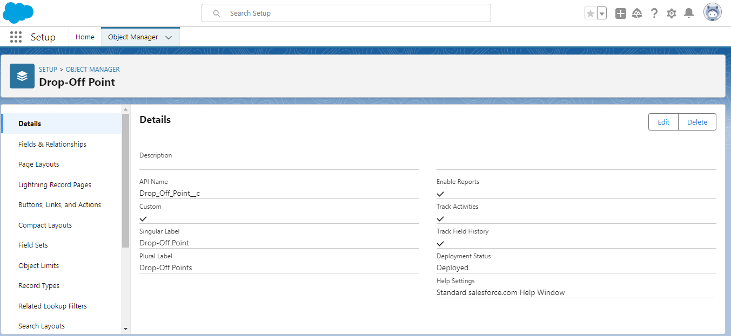

1. **Create Task Object**

To create an object:

From the setup page >> Click on Object Manager >> Click on Create >> Click on Custom Object.

Enter the label name>> Task

Plural label name>> Tasks

Enter Record Name Label and Format

Record Name >> Task Name

Data Type >> Text

Click on Allow reports and Track Field History,Allow Activities

Allow search >> Save.

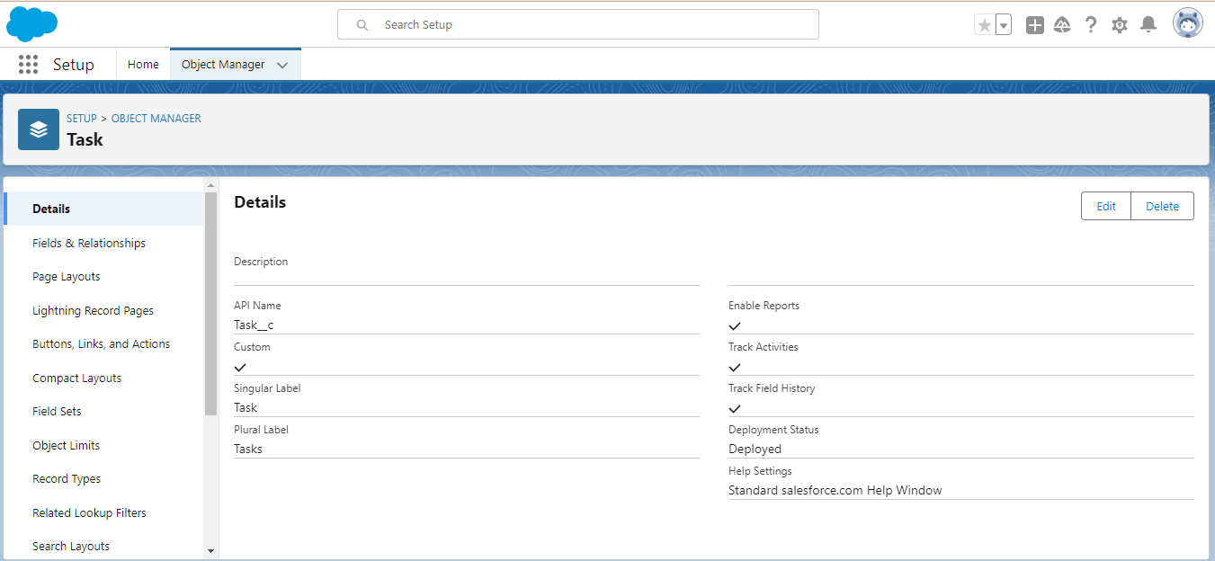

1. **Create Volunteer Object**

To create an object:

From the setup page >> Click on Object Manager>> Click on Create >> Click on Custom Object.

Enter the label name>> Volunteer

Plural label name>> Volunteers

Enter Record Name Label and Format

Record Name >> Volunteer Name

Data Type >> Text

Click on Allow reports and Track Field History, Allow Activities

Allow search >> Save.

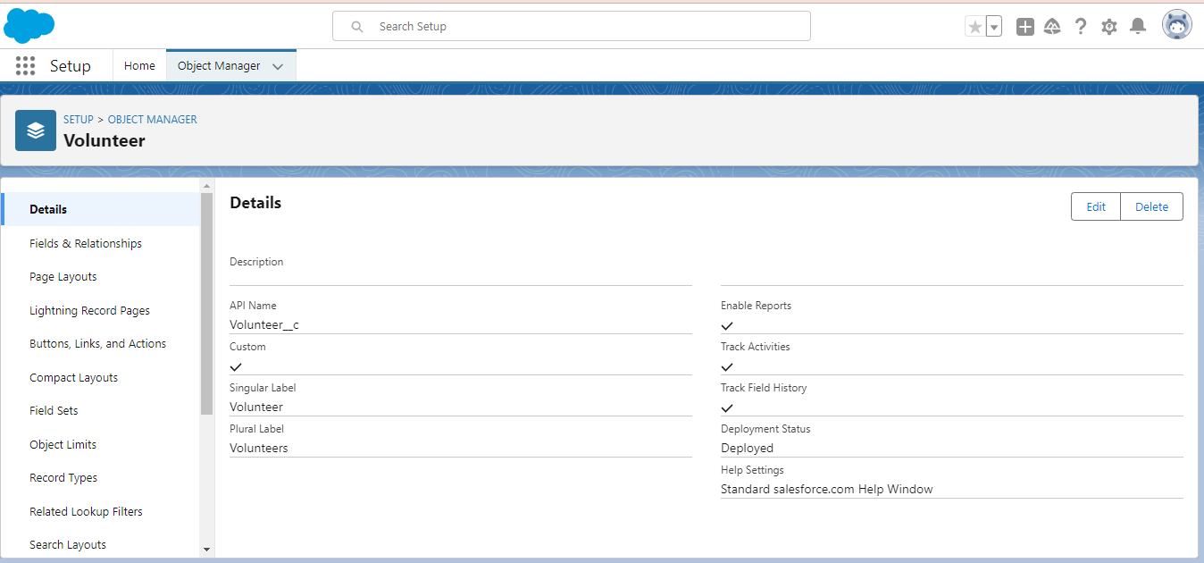

1. **Create Execution Details Object**

To create an object:

From the setup page >> Click on Object Manager >> Click on Create >> Click on Custom Object.

Enter the label name >> Execution Detail

Plural label name >> Execution Details

Enter Record Name Label and Format

Record Name >> Execution Detail Name

Data Type >> Text

Click on Allow reports and Track Field History, Allow Activities

Allow search >> Save.

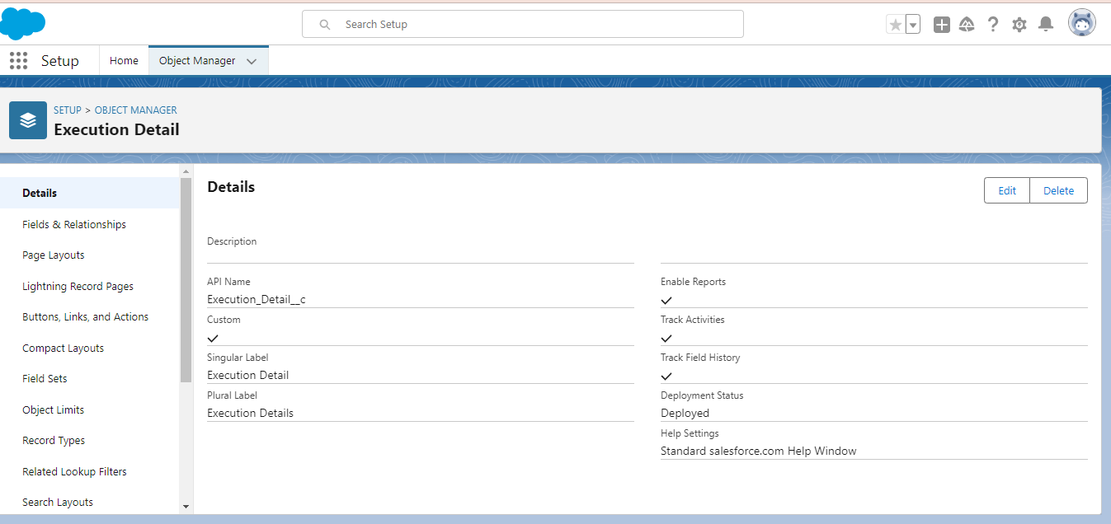

**TABS**

A tab is like a user interface that is used to build records for objects and to view the records in the objects.

**Creating a Custom Tab**

To create a Tab:(Venue)

1. Go to setup page >> type Tabs in Quick Find bar >> click on tabs >> New (under custom object tab)
2. Select Object(Venue) >> Select the tab style >> Next (Add to profiles page) keep it as default >> Next (Add to Custom App)  uncheck the include tab .
3. Make sure that the Append tab to users' existing personal customizations is checked.
4. Click save

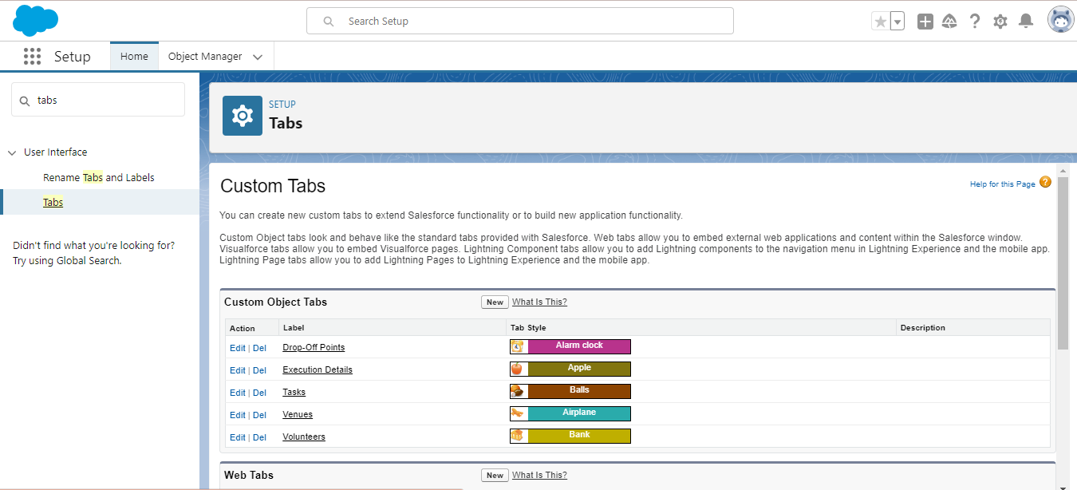

**Creating Remaining Tabs**

1. Now create the Tabs for the remaining Objects, they are “Drop-Off Point, Task, Volunteer, Execution Details”.
2. Follow the same steps as mentioned above

**THE LIGHTNING APP**

An app is a collection of items that work together to serve a particular function. In Lightning Experience, Lightning apps give your users access to sets of objects, tabs, and other items all in one convenient bundle in the navigation bar.

**Create a Lightning App**

**To create a lightning app page:**

1. Go to setup page >> search “app manager” in quick find >> select “app manager” >> click on New lightning App.
2. Fill the app name in app details and branding as follow  
   App Name : FoodConnect  
   Developer Name : This will auto populated  
   Image : optional (if you want to give any image you can otherwise not mandatory) Primary color hex value : keep this default.
3. Then click Next  >> (App option page)Set Navigation Style as Standard Navigation >> Next.
4. (Utility Items) keep it as default >> Next.
5. To Add Navigation Items:

Search for the item in the (Home, Venue, Drop-Off Point, Task, Volunteer, Execution Details, Reports) from the search bar and move it using the arrow button >> Next >> Next.

1. To Add User Profiles:

Search profiles (System administrator) in the search bar >> click on the arrow button >> save & finish.

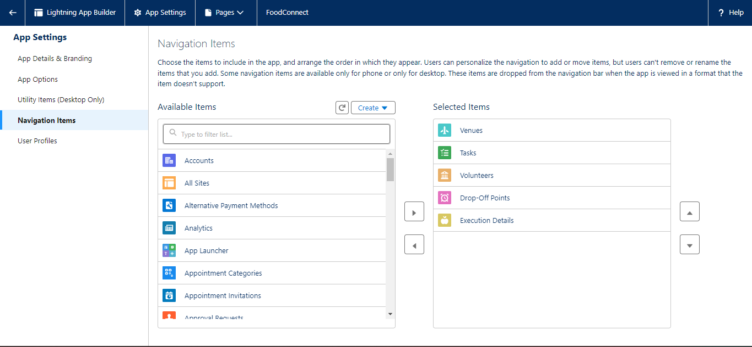

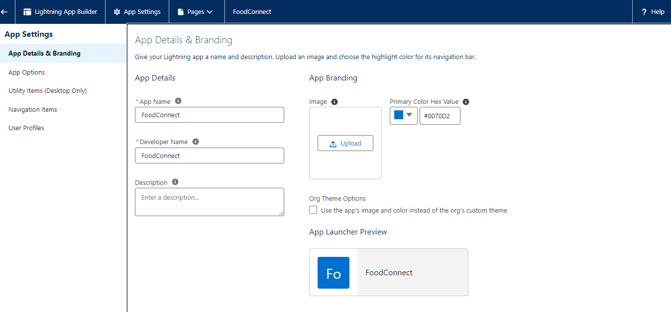

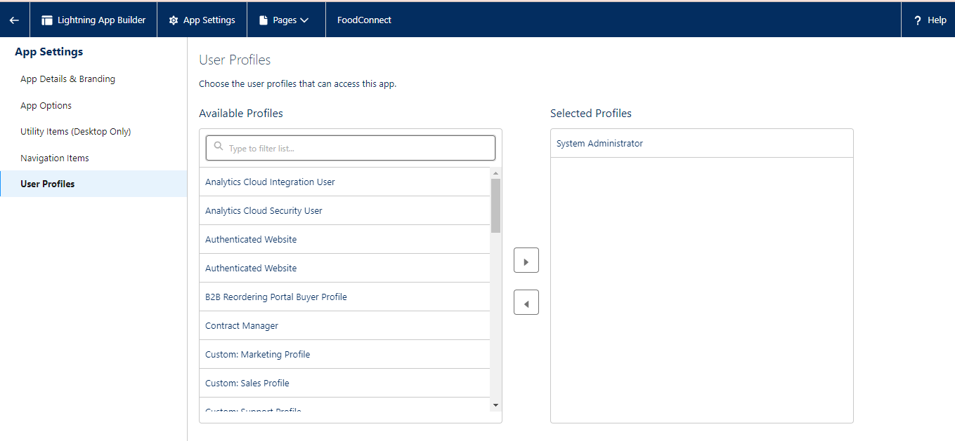

**FIELDS**

**Creation of Lookup Relationship Field on Volunteer Object :**

1. Go to setup >> click on Object Manager >> type object name(Volunteer) in the search  bar >> click on the object.
2. Now click on “Fields & Relationships” >> New
3. Select Master Detail relationship
4. Select the related object “Drop-Off point” and click next.
5. Field Name : Drop_Off_point
6. Field label : Auto generated
7. 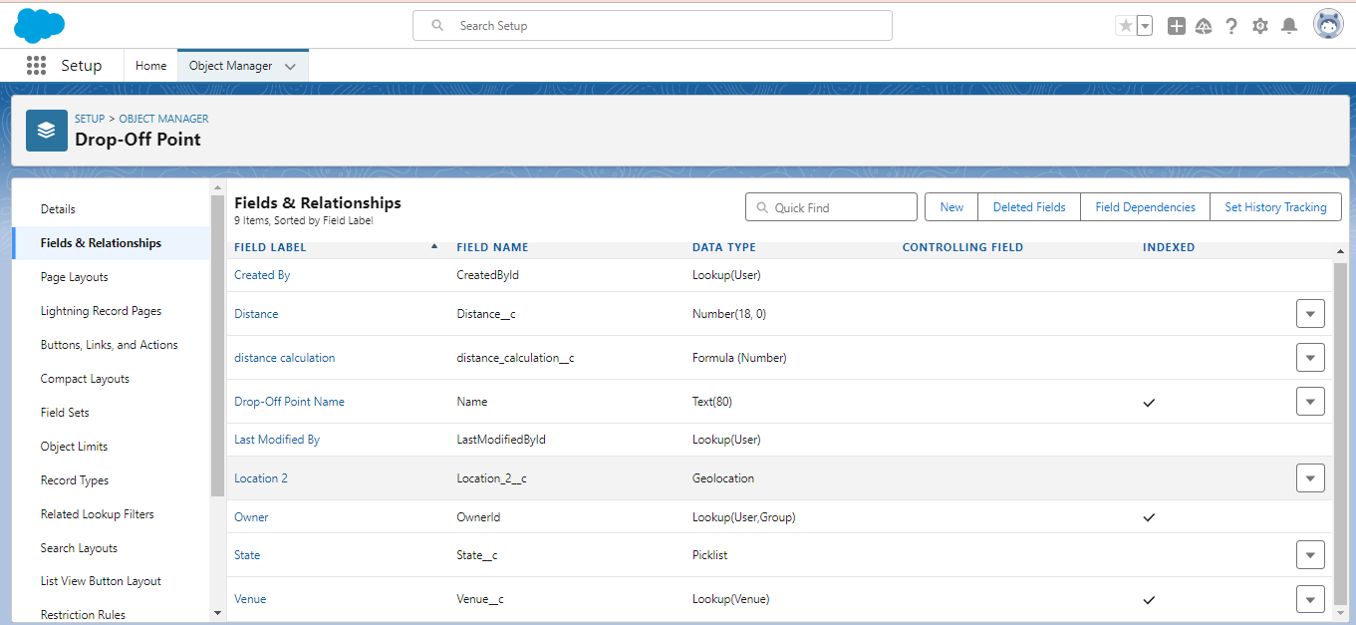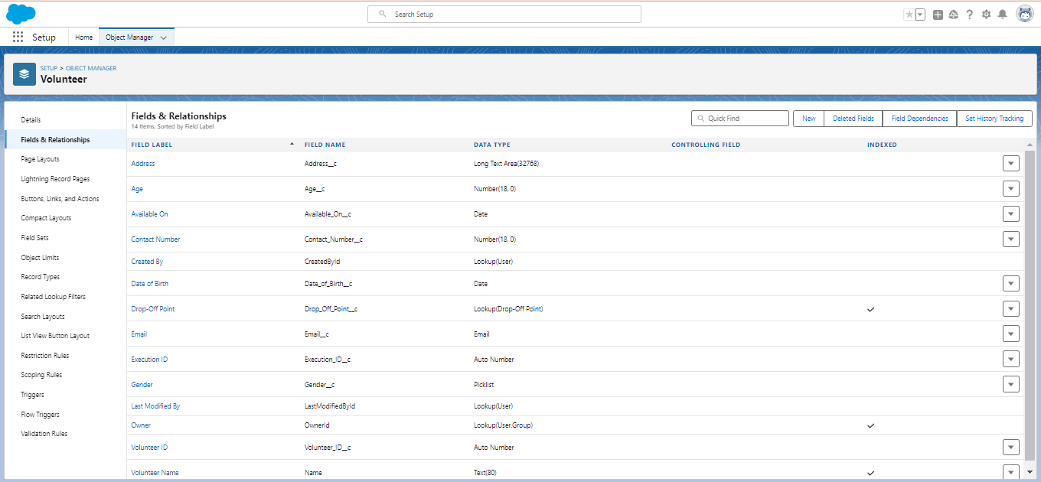Next >> Next >> Save.

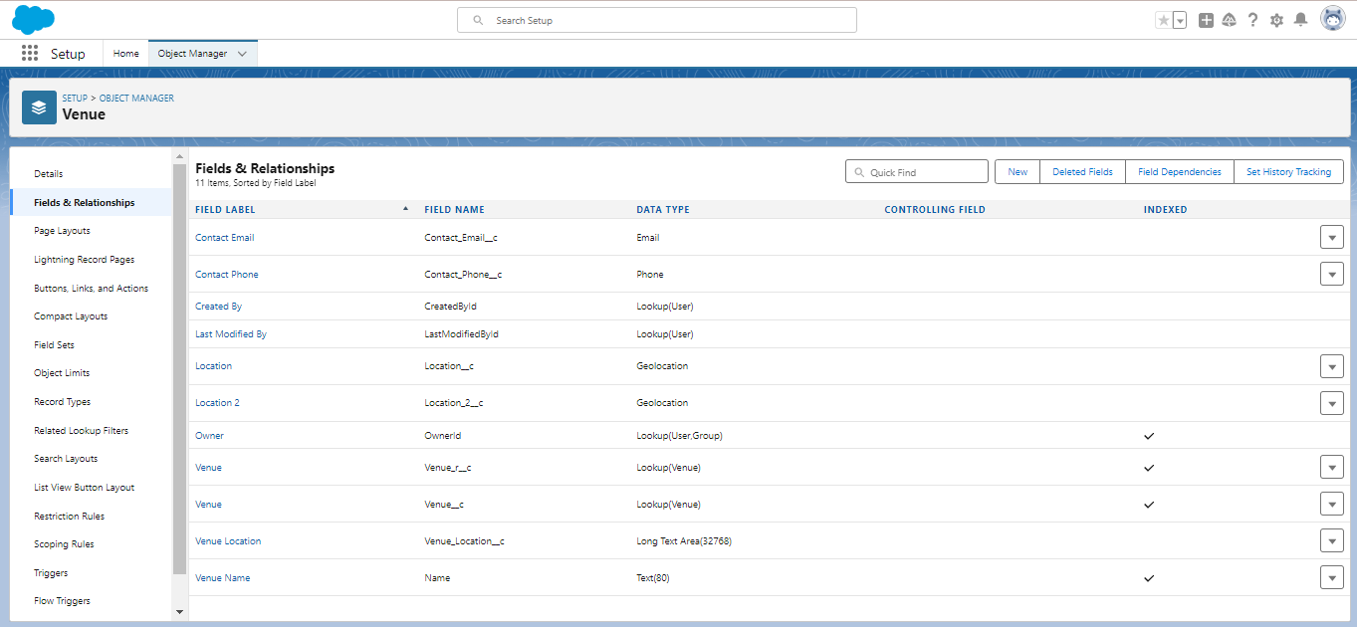

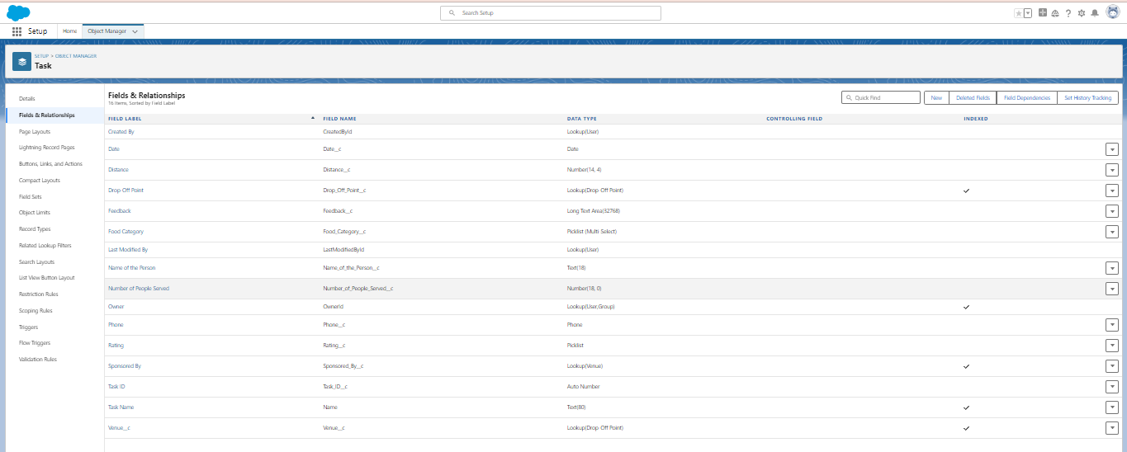

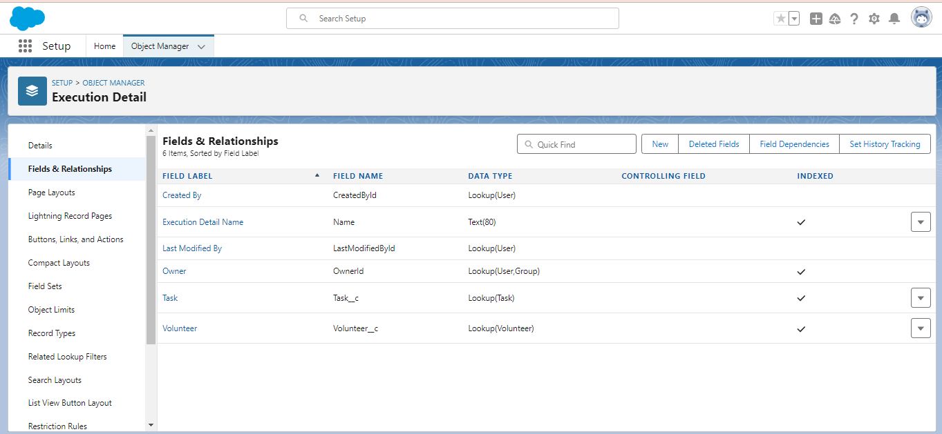

**FLOWS**

**Create Flow to create a record in Venue object**

1. Go to setup >> type Flow in quick find box >> Click on the Flow and Select the New Flow.
2. Select the Screen flow. Click on create.
3. Click on the ‘+’ icon in between start and end, and click on screen element.
4. Under the Screen Properties:

Label : Venue Details

API Name : Venue_Details

1. Now lets add components in this flow. Click on Text Component and name it as:

Label : Venue Name

API Name : Venue_Name

1. Click on Email Component and name it as:

Label : Email

API Name : Contact_Email

1. Click on Phone Component and name it as:

Label : Phone

API Name : Contact_Phone

1. Click on Text Component and name it as:

Label : Venue Location

API Name : Venue_Location

1. Click on Number Component and name it as:

Label : Latitude

API Name : Latitude

1. Click on Number Component and name it as:

Label : longitude

API Name : longitude

1. Next click on Done. This would like below
2. Click on the ‘+’ icon in between Venue details and end, and click on create record element.
3. Now label it as

Label : Create Venue Record

API Name : Create_Venue_Record

How Many Records to Create : One

How to Set the Record Fields : Use separate resources, and literal values

Object : Venue

Set Field Values for the Venue : Click on ‘Add Field’ 5 times

Field : Value = Contact_Email__c : {!Contact_Email.value}

Field : Value = Contact_Phone__c : {!Contact_Phone.value}

Field : Value = Name : {!Venue_Name}

Field : Value = Venue_Location__c : {!location}

Field : Value = Location__Latitude__s : {!latitude}

Field : Value = Location__Longitude__s : {!longitude}

1. This would look like:
2. Click on Save as:

Flow Label : Venue Form

Flow API Name : Venue_Form

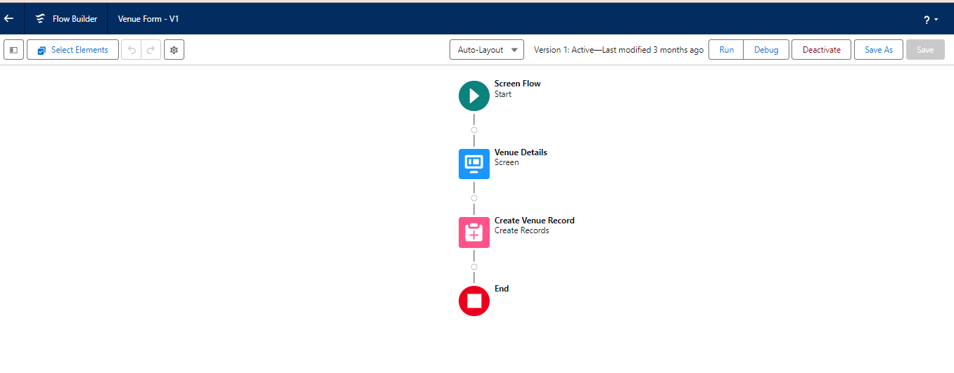

**TRIGGERS**

**Create a Trigger**

1. Log into the trailhead account, navigate to the gear icon in the top right corner.
2. Click on developer console and you will be navigated to a new console window.
3. Click on the File menu in the toolbar, and click on new >> Trigger.
4. Enter the trigger name and the object to be triggered.
5. Enter Name : DropOffTrigger

sObject: Drop-Off Point

1. Click on Submit.

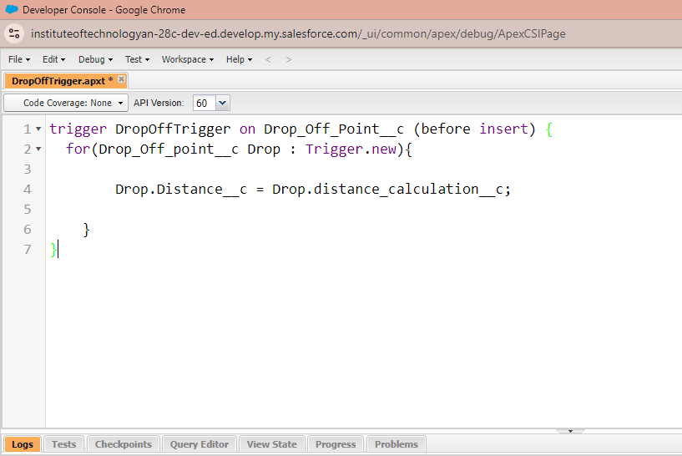

To create a matching rule to an Customer details Object

1. Go to quick find box in setup and search for matching Rule.
2. Click on matching rule >> click on New Rule.
3. Select the object as Customer details and click Next.
4. Give the Rule name : Matching customer details
5. Unique name : is auto populated
6. Define the matching criteria as
7. Field Matching Method
   1. Gmail Exact
   2. Phone Number Exact
8. Click save.
9. After saving click on activate

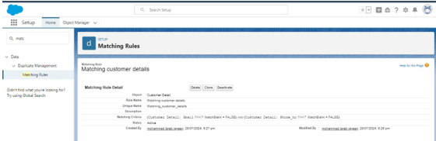

**PROFILES**

1. Go to setup page >> type Profiles in Quick Find bar >> click on Profiles >> click on ‘S’
2. Click on Clone beside Standard Platform User.
3. Under Clone Profile:

Profile Name : NGOs Profile

1. Then click on Save

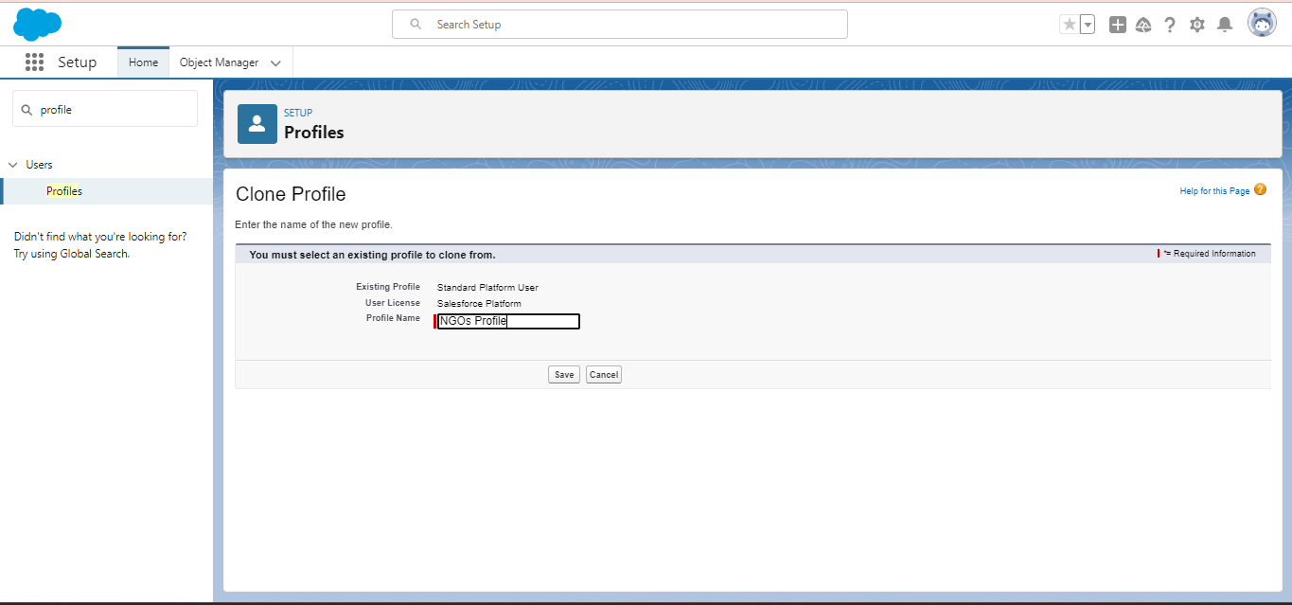

**CREATION OF USERS**

In our Project we consider them as NGO’s

**Creation of User1**

1. Go to setup page >> type users in Quick Find bar >> click on users>> New user.
2. In General Information give details as: (Note : create users as per your wish NGO’s)

First Name : Iksha Foundation

Last Name : Iksha_Foundation

Alias : iiksh

Email : Give Your Email

Username : [ikshafoundation@sb.com](mailto:ikshafoundation@sb.com) (give the username different)

Nickname : Auto Populated

User License : Salesforce Platform

Profile : NGOs Profile

Active : Check

1. Click on Save

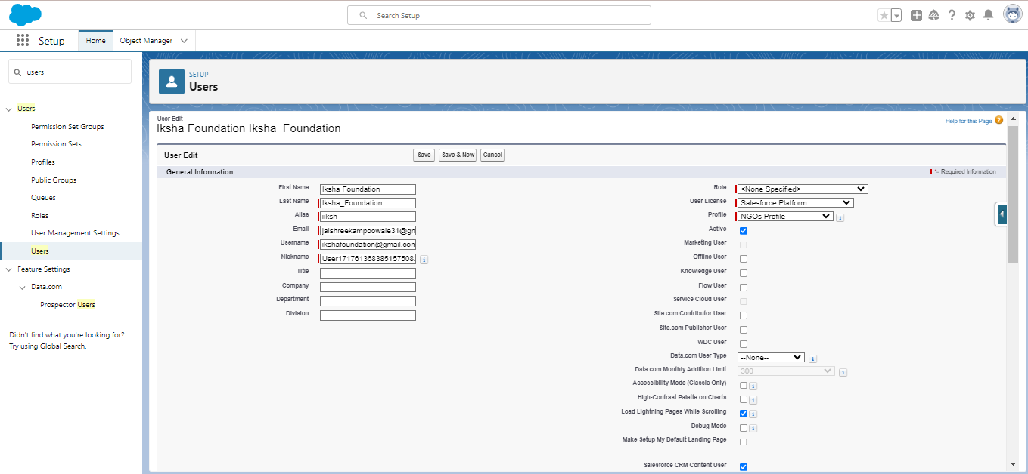

**Creation of User2, User3**

1. Create another Two Users by following steps in Activity - 1 with similar User License and Profile.
2. Give Different First Name, Last Name based on Different NGO’s.

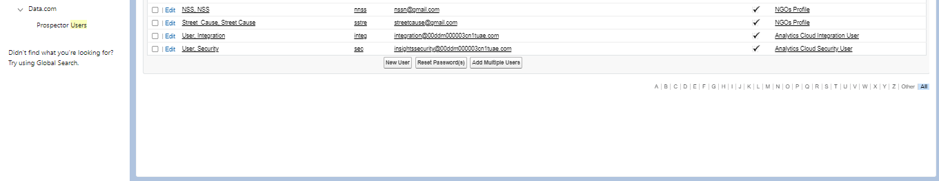

**PUBLIC GROUPS**

Creation of Public Group 1

1. Go to setup page  >>  type Public Groups in Quick Find bar  >>  click on Public Groups >>  click on New.
2. Under Group Information:

Label : Iksha

Group Name : Iksha

Grant Access Using Hierarchies : Check

1. In Search, Select Users.
2. In Selected Members Add Iksha Foundation and System Administrator

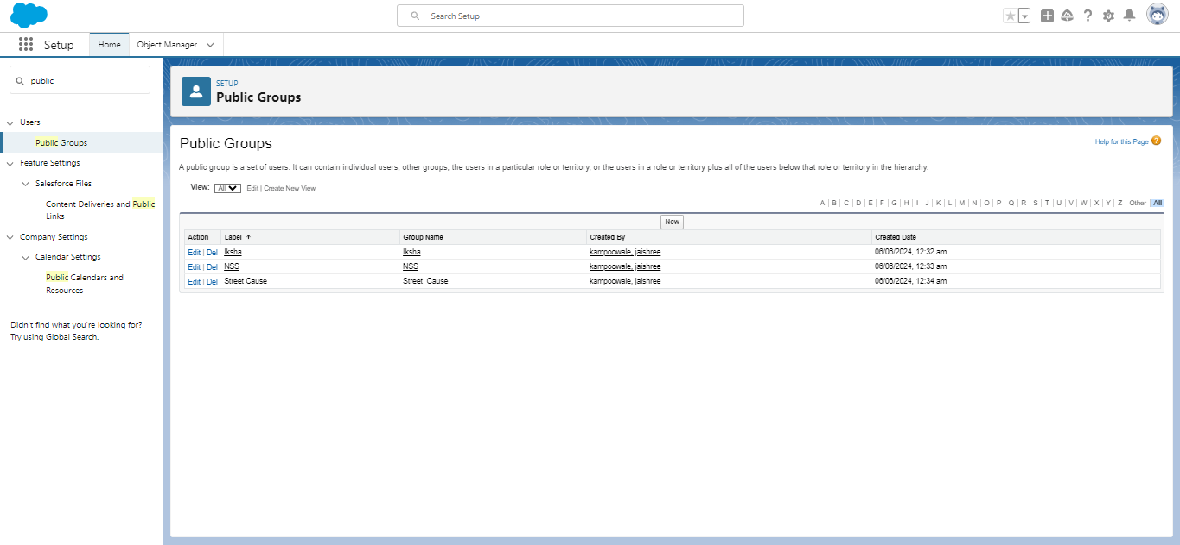

Creation of Public Group 2

1. By Following Steps in Activity 1, Create other  two Public Groups for other two users.
2. After Saving this would look like this.

**REPORT TYPES**

Creation of Report Types

1. Go to setup page  >>  type Report Types in Quick Find bar  >> click on Report Types  >>  click on Continue   >>  Click on New Custom Report Type.
2. In Define the Custom Report Type:

Primary Object : Select Venues

Report Type Label : Venue with DropOff with Volunteer

Report Type Name : Venue_with_DropOff_with_Volunteer

Description : Venue with DropOff with Volunteer

Store in Category : Select Other Reports

Deployment Status : Deployed

1. Click on Next
2. Near Click to relate another Object Select Drop-Off Points.
3. And also select "A" records may or may not have related "B" records.
4. Now again Near Click to relate another Object Select Volunteers.
5. Now click on Save

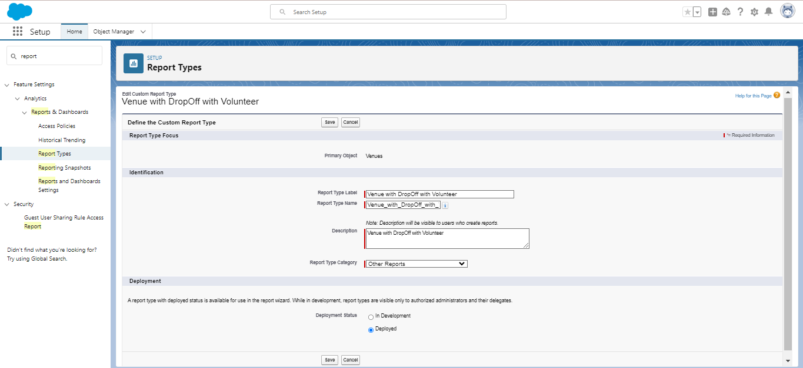

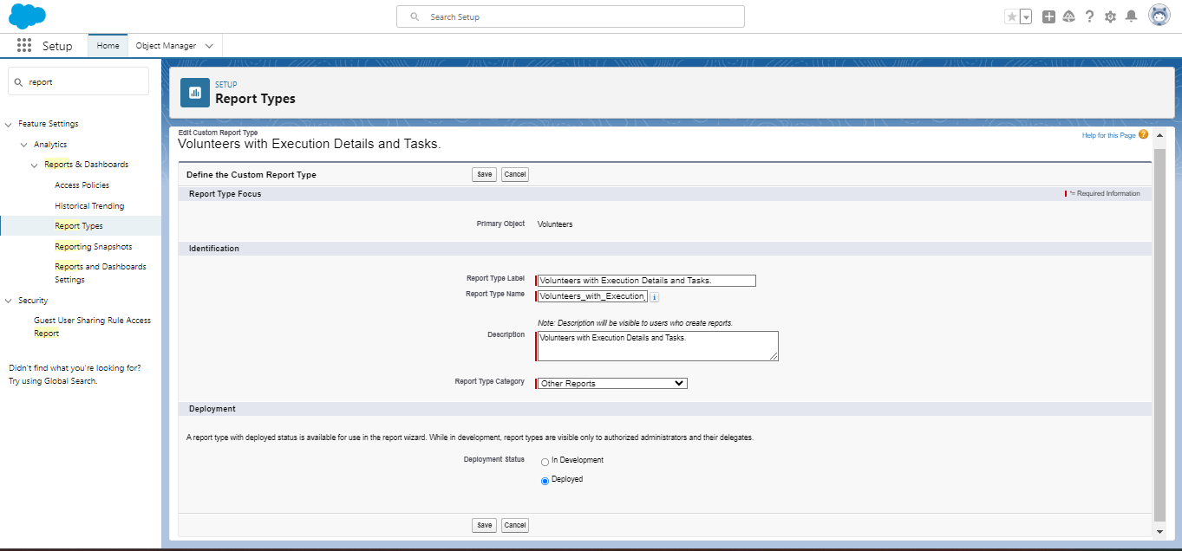

##### **REPORTS**

**Creation of Report on Venue with DropOff with Volunteer**

1. Go to the app(FoodConnect)  >>  click on the reports tab
2. Click on New Folder.

Folder Label : Custom Reports

Folder Unique Name : CustomReports

1. Open Custom Reports and click on New Report
2. Select Report Type : Venue with DropOff with Volunteer
3. Then click on Start Report.
4. In GROUP ROWS : Add Volunteer Name
5. In Columns : Add Venue Name, Drop-Off point Name, Distance.
6. Now click on Save & Run.
7. Give Label as :
8. Report Name : venue and Drop Off point
9. Report Unique Name : Auto Populated
10. Click on Select Folder and select Custom Report, then click on Save.

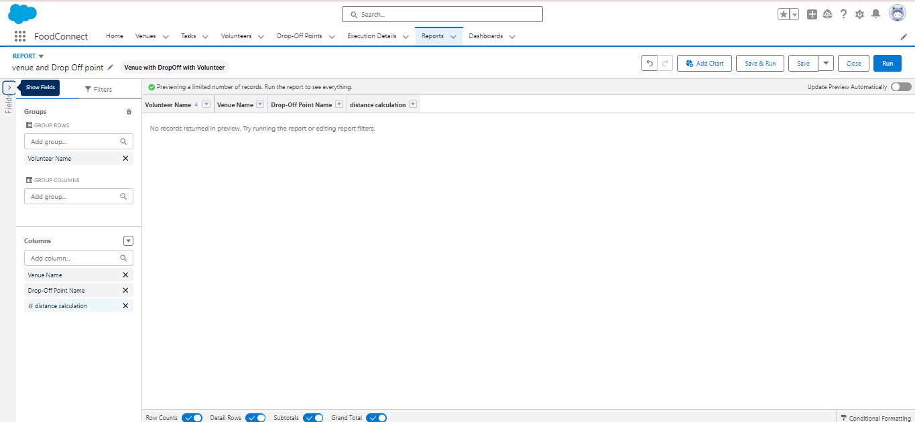

**Creation of Report on Volunteers with Execution Details and Tasks**

1. Go to the app(FoodConnect)  >>  click on the reports tab
2. Click on Custom Reports Folder and click on New Report
3. Select Report Type : Volunteers with Execution Details and Tasks.
4. Then click on Start Report.
5. In GROUP ROWS : Volunteer ID
6. In Columns : Add Volunteer : Volunteer Name, Task : Task Name, Execution Detail : Execution Detail Name, Volunteer: Owner Name, Task: Date, Task : Rating.
7. Now click on Save & Run.
8. Give Label as :

Report Name : Volunteer Task

Report Unique Name : Auto Populated

1. Click on Select Folder and select Custom Report, then click on Save.

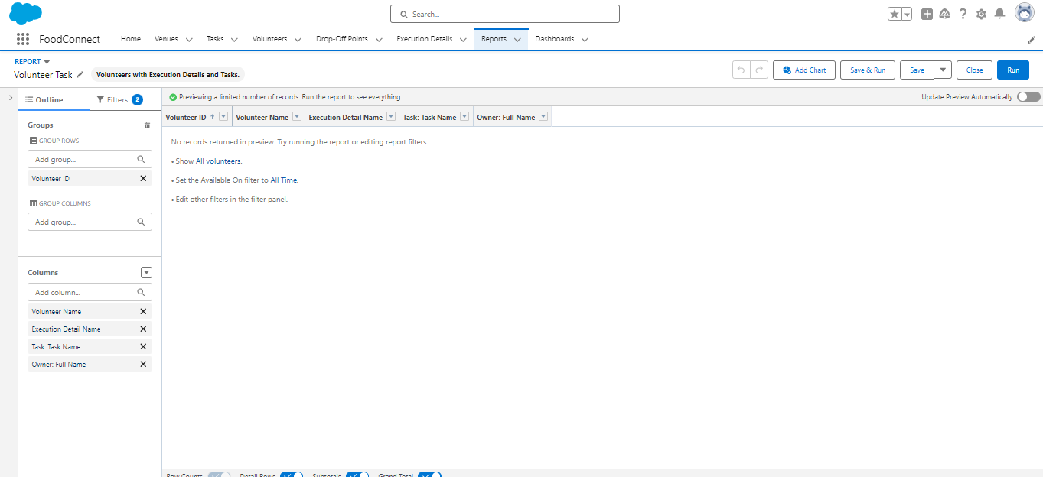

**DASHBOARDS**

Adding venue and Drop Off point Report to the Dashboard

1. Go to the app(FoodConnect)  >>  click on the Dashboards tab.
2. Click on New Folder.

Folder Label : Custom Dashboards

Folder Unique Name : Auto Populated

1. Open Custom Dashboards and click on New Dashboards
2. Name : Organization Details
3. Click on Widget and select Chart or Table
4. In Select Report : Select venue and Drop Off point Report.
5. Then click on select
6. In Add Component:

Display As : Select Lightning Table

Component Theme : Select Dark (Optional)

1. Now click on save.

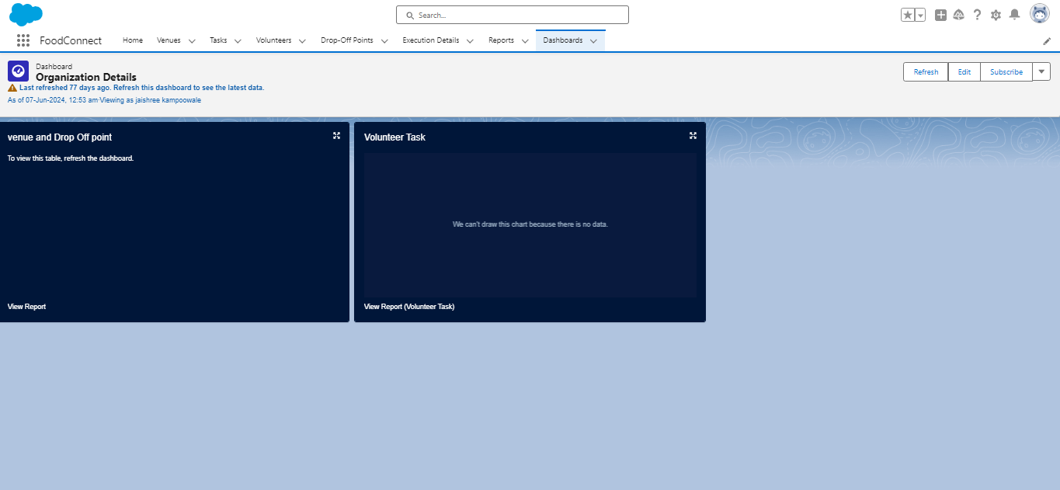

**SHARING RULES**

**Creation of sharing rules**

1. Go to setup  >>  type Sharing Settings in quick find box  >>  Click on the Sharing Settings.
2. Scroll down and find Drop-Off point Sharing Rules.
3. Click on new near Drop-Off point Sharing Rules and Name it as:

Label : Rule 1

Rule Name : Rule_1

1. Select your rule type : Select Based on criteria.
2. Select which records to be shared:

Field : Operator : Value = Distance : less than : 15

1. Select the users to share with : Near Share With

Public Groups : Iksha

1. Click on Save.
2. Click on new near Drop-Off point Sharing Rules and Name it as:

Label : Rule 2

Rule Name : Rule_2

1. Select your rule type : Select Based on criteria.
2. Select which records to be shared:

Field : Operator : Value = Distance : greater than : 15

Field : Operator : Value = Distance : less or equal : 30

1. Select the users to share with : Near Share With

Public Groups : NSS

1. Click on Save.
2. Click on new near Drop-Off point Sharing Rules and Name it as:

Label : Rule 3

Rule Name : Rule_3

1. Select your rule type : Select Based on criteria.
2. Select which records to be shared:

Field : Operator : Value = Distance : greater than : 30

Field : Operator : Value = Distance : less or equal : 50

1. Select the users to share with : Near Share With

Public Groups : Street Cause

1. Click on Save.

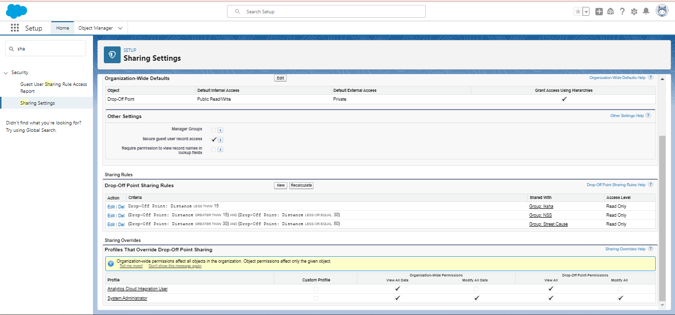

**HOME PAGE**

Creation of Home Page

1. Go to setup >> type Lightning App Builder in quick find box  >>  Click on the Lightning App Builder and Select the New.
2. Select Home Page and give Label as HOME Page.
3. Select Standard Home Page.
4. Near Components search for Flow and Drag and Drop in Right Side Section..
5. On the right hand side:

Flow : Venue Flow

1. Near Components search for Dashboard, then Drag and Drop it in first Section.
2. Click on Save and Activation, then click on App Default, then Add Assignments.
3. Add FoodConnect App and then Save.
4. FoodConnect Home Page would Look Like this.

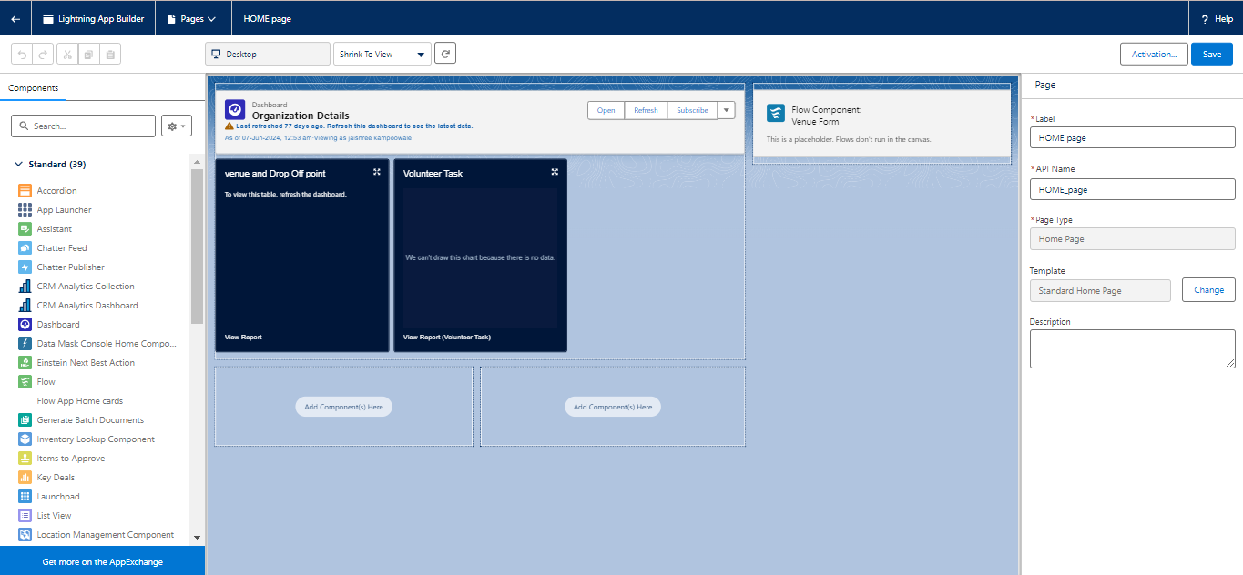

**CONCLUSION**

The Salesforce-based food redistribution project effectively tackles both food waste and hunger by developing a well-organized, efficient system for managing surplus food. By utilizing custom objects such as Venue, Dropoff Point, Task, Volunteer, and Execution Details, the platform ensures meticulous tracking and management of every stage of the food donation and distribution process.

The project enhances operational efficiency by automating key tasks, optimizing logistics, and delivering real-time data insights. This approach ensures that volunteers are well-coordinated, food is delivered promptly and safely, and the system remains responsive to the needs of both donors and recipients.

In essence, this project highlights how Salesforce can be harnessed to create scalable and sustainable solutions that benefit both communities and the environment. It serves as a model for how technology can address critical social issues, providing a framework that other communities around the world can adapt to combat food insecurity.